Page: 1

LEVEL: INTERMIDIATE

PROJECT GUIDE

PYTHON BASED GUESING GAME

AUTHOR: omm prakash das

***INTRODUCTION:***

In this project you will learn to build you will build a number guessing game using python.

Now let`s start building.

FIRST let`s create the python file.

Create a python file with the name you want.

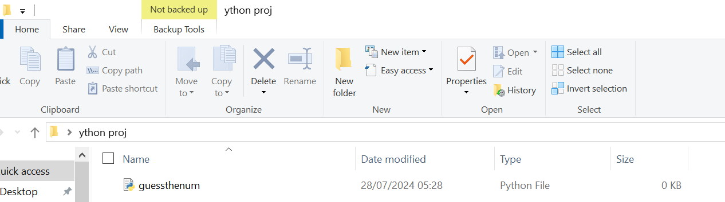

Then open your preferred IDE or IDLE etc.

Then we will start programing.

***BASICS:***

So before we start programing take a notebook or a note take taking application.

And note down what speciality you need and what not.

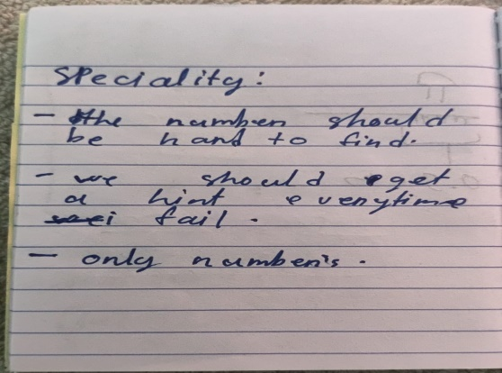For this example am going to create a project with these notes.

|  |
| --- |
| -the number should be hard to find. |
| -we should get a hint every time I fail. |
| -only numbers |

Written neatly.

Page: 2

Now as we know what we need to build we can start programing.

Let`s start by building a function using the def keyword.

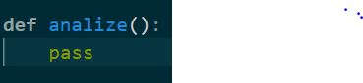

Here we have just written pass which make the func useless.

Let`s add some code but before we start.

NOTE:

It’s a good practice to use functions it makes the code readable, clean, usable, reusable, looks professional.

Now I’ve added a another func to generate a random number between 1 to your number of

choice.

We will use the random module.

It’s built in to use it just add this line of code first:



You have to do this before using the random module.

(?)Now I want you to try write your own function which returns a random int.

Hint: use the randint() and use return.

(^-^)…….

You should end up with this.

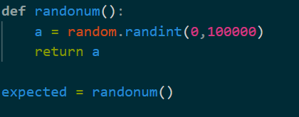

Well now I’ve used the function and stored I value in a variable named expected.

Well now code another function to take an input and compare it with expected {variable}.

You should end up here:

Page: 3

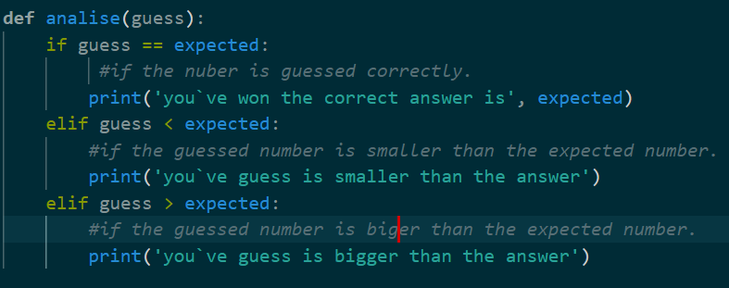

Now use the input() function and put it in an int() function so that the number typed is an int.

And store it in guess variable.

You will end up here:



At last call the function which determines the correct number and you are up.

At last you will be here:

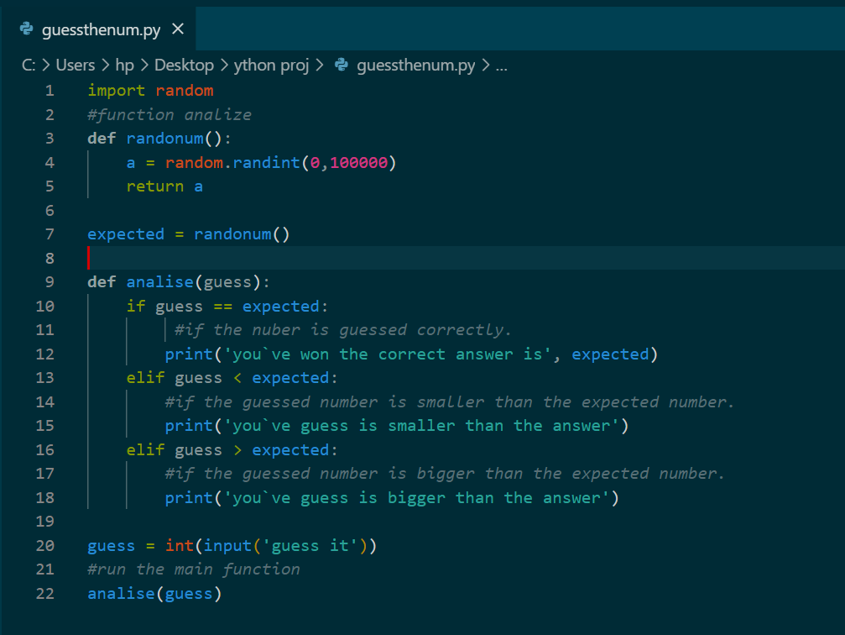

THANK YOU FOR READING THIS BOOK. (^-<””>-^)

By: omm prakash das --created on 10/9/2024